### Use Case 1: Station Mode Wi-Fi Connection

This use case is to demonstrate the station mode configuration and connecting to the Wi-Fi Access Point.

Execute the following operations on the Talaria TWO:

**Step 1**: Scan the network.

**Step 2**: Connect to the desired network by providing SSID and passphrase

**Step 3**: Get the IP address of the Talaria TWO module

**Step 4**: Get the WLAN status of the Talaria TWO module

**Step 5**: Disconnect from the connected network

|  |  |
| --- | --- |
| **Command** | **Description** |
| *./conmgr scan* | Scan |
| *./conmgr connect <SSID><AP PWD>* | Connect |
| *./conmgr ip* | Get IP address |
| *./conmgr status* | Get WLAN status |
| *./conmgr disconnect* | Disconnect |

Table 1: Station Mode Wi-Fi Connection – Commands

Console outputs:

1. ./conmgr scan

Figure 9: ./conmgr scan – output

1. ./conmgr connect innotest 123456789

Figure 10: ./conmgr connect - output

1. ./conmgr ip

Figure 11: ./conmgr ip – output

1. ./conmgr status

Figure 12: ./conmgr status – output

1. ./conmgr disconnect

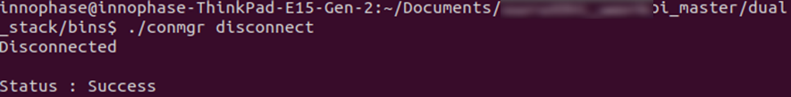

Figure 13: ./conmgr disconnect – output